Princess Sumaya University for Technology

King Abdullah II Faculty of Engineering

Computer Engineering Department



|  |
| --- |
| **22442**  **Embedded Systems**  **Fire Fighter** |

Authors: Supervisor:

Emad Toffaha 20210025 Communications Engineering Dr. Belal Sababha

Abdullah Alqudah 20210252 NIS Engineering

Bader Albarghothi 20210024 Computer Engineering

# **Abstract**

The firefighting robot aims to autonomously detect and suppress fires with precision and efficiency. Equipped with a PIC16F877A microcontroller, three 3.7 Batteries, flame sensors to detect the fire from all angles, servo motor to spray the water precisely when it gets near the fire, DC motors to move the robot and rotate the robot freely and easily, and an ultrasonic sensor to detect the water level in the tank and alert if the water level in the tank is low.

Table of Contents

Abstract 2

Introduction 2

Background 3

Figure (1): PIC16F877A 3

Figure (2): Analog Flame Sensor 4

Figure (3): Digital Flame Sensor 4

Figure (4): H-Bridge 5

Figure (5): DC Motor 5

Figure (6): Servo Motor 6

Figure (7): Water Pump 6

Figure (8): Ultrasonic Sensor 7

Design 7

Flowchart: 8

Electrical Design : 9

Problems and Recommendations : 9

1. Problems : 9

2. Recommendations : 9

Conclusion : 10

# **Introduction**

Firefighting robots are designed to combat fires in hazardous or inaccessible areas, reducing risks to human firefighters. This project introduces a firefighting robot controlled by the PIC16F877A microcontroller, known for its reliability and versatility.

The robot uses digital and analog flame sensors to detect fires and navigate autonomously. The PIC16F877A processes sensor data and controls the robot's movement and fire-extinguishing mechanisms, showcasing how microcontroller-based systems can improve firefighting safety and efficiency.

# **Background**

The PIC16F877A is a widely used 8-bit microcontroller known for its versatility and reliability. It features 40 pins, multiple I/O ports, and built-in peripherals like analog-to-digital converters and PWM modules, making it ideal for a range of applications. Its simplicity and low power consumption make it a popular choice for embedded systems, including robotics and automation projects.

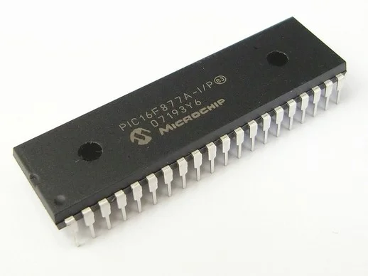

### Figure (1): PIC16F877A

An analog flame sensor is a device used to detect the presence of a flame or fire by sensing infrared light emitted by flames. It provides an analog voltage output proportional to the intensity of the flame, which can be processed by a microcontroller for fire detection and response. Compact and efficient, it is widely used in fire detection systems and robotics.

### Figure (2): Analog Flame Sensor

digital flame sensor is a device designed to detect the presence of a flame or fire by sensing infrared light emitted by flames. Unlike analog sensors, it provides a binary output—either HIGH or LOW—indicating the presence or absence of a flame. Simple and reliable, it is commonly used in fire detection systems and automated safety applications.

### Figure (3): Digital Flame Sensor

An H-bridge is an electronic circuit used to control the direction of a DC motor by reversing its polarity. It allows the motor to rotate in both forward and reverse directions using input signals. Widely used in robotics and motor control applications, H-bridges are efficient and simple to implement, making them essential for projects requiring precise motor control.

### Figure (4): H-Bridge

A DC motor is an electromechanical device that converts electrical energy into mechanical energy through the interaction of magnetic fields. It is widely used in various applications due to its ability to provide precise speed and direction control. DC motors are efficient, versatile, and commonly employed in robotics, automation, and other systems requiring reliable rotational motion.

### Figure (5): DC Motor

A servo motor is a compact and precise electromechanical device used for position and speed control in various applications. It operates using a feedback mechanism to achieve accurate angular movement, making it ideal for tasks requiring precision, such as robotics, automation, and remote-controlled systems. Servo motors are reliable, efficient, and easy to integrate into projects needing controlled motion.

### Figure (6): Servo Motor

A water pump is a mechanical device designed to move water from one location to another efficiently. It is widely used in various applications, such as irrigation systems, water supply, and cooling systems. Water pumps are reliable, versatile, and available in different types, making them suitable for projects that require controlled water flow and pressure.

### Figure (7): Water Pump

An ultrasonic sensor is a device that uses sound waves to measure the distance between the sensor and an object. It emits ultrasonic pulses and calculates the distance based on the time it takes for the echo to return. Ultrasonic sensors are widely used in robotics, automation, and obstacle detection due to their accuracy, reliability, and ability to function in various environments.

### Figure (8): Ultrasonic Sensor

# **Design**

The ultrasonic gives the robot a read about the water level in the tank, if the water is level is low the robot won’t turn on to ensure the safety of the water pump, when the fire is detected through the digital sensors, the robot turns towards the fire through the 4 wheels to make it facing the analog sensor, after the fire is detected by the analog flame sensor the pump is enabled and the servo is enabled to make the pipe turn slightly left and right to extengiush the fire from all angles.

The working mechanism of the firefighting robot is shown in figure (1) below.

## **Flowchart:**

## **Electrical Design :**

# **Problems and Recommendations :**

## **Problems :**

1. We used 2 wheels based chassis at first and it did not handle the weight of the pump and the tank.
2. We used 3 1.5 batteries at first but they didn’t give enough voltage for the H-Bridge to work correctly.
3. We made the power switch turn off and on after the H-Bridge, it drained the batteries quickly and they became empty.

## **Recommendations :**

1. Use 4 wheels chassis to handle the weight of the tank and pump.
2. Use 3 3.7 Batteries to give the H-Bridge enough voltage to work correctly.
3. Make the power switch work on and off before the H-Bridge to ensure no power is drained.

# **Conclusion :**

In conclusion, the design of the firefighter robot integrates essential components to create an efficient and reliable system for fire detection and suppression. By combining sensors, motor controls, and a firefighting mechanism, all coordinated by the PIC16F877A microcontroller, the robot is capable of operating autonomously in hazardous environments. This innovative design demonstrates the potential of robotics to enhance safety and efficiency in fire management applications.